14-18 September 2016

AEC International Relations Coordinators Meeting, Krakow

Reservation password: IRC KRAKOW2016

Please make your hotel reservation till 15.07.2016
Please note that Krakow is a very popular place and September
is a very popular period among tourists.
If hotels are full, please try to make a reservation through any internet portal (such as booking.com)

DS – DORMITORY
OF THE ACADEMY OF MUSIC IN KRAKOW
ul. Przemyska 3, 31-036 Kraków, Polska
Walking distance: 15 minutes from the Academy of Music in Kraków
Located in Kazimierz, the historical district of Kraków, DS Akademia Muzyczna is 1.5 km from the Wawel Castle. It offers accommodation with free wired internet access.
Breakfast: 10 PLN
Booking e-mail: katarzyna.druzgala@amuz.krakow.pl
Prices per person/room: 90 PLN

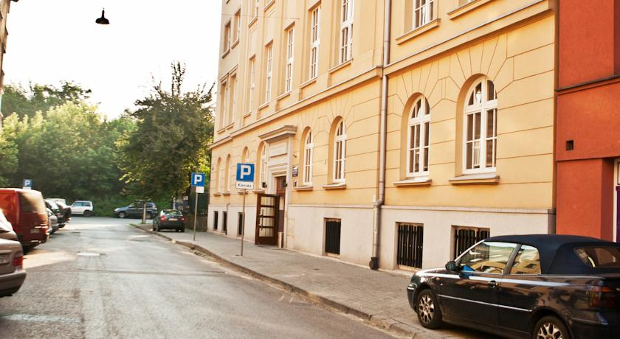

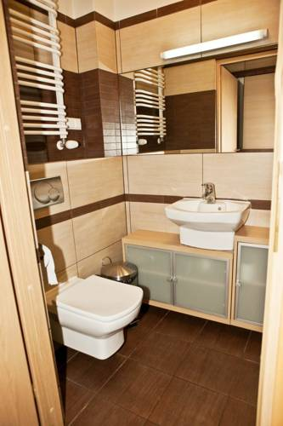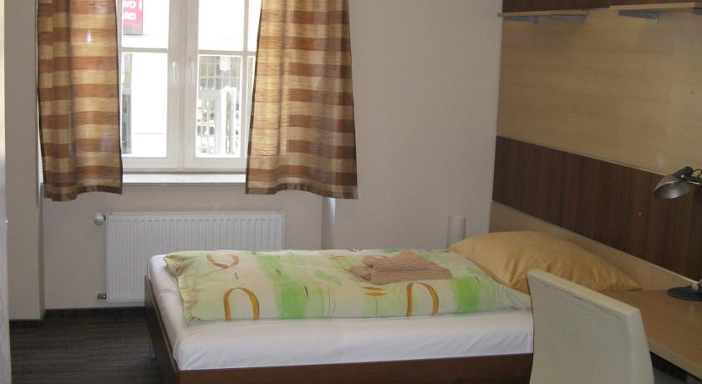

INGO APARTHOTEL / www.hotelingo.pl
ul. Mikołajska 17-19, 31-027 Kraków
Walking distance: 1 minutes from the Academy of Music in Kraków
Services: free wireless internet, satellite TV
Breakfast: included
Booking e-mail: biuro@hotelingo.pl
Prices per person/room: 280 PLN

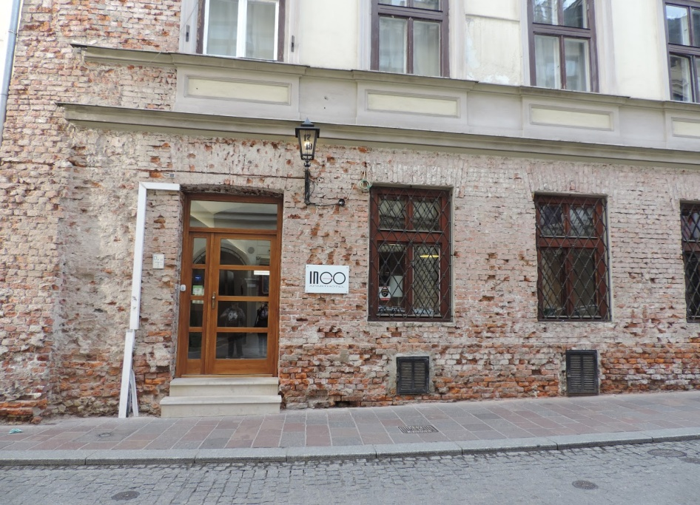
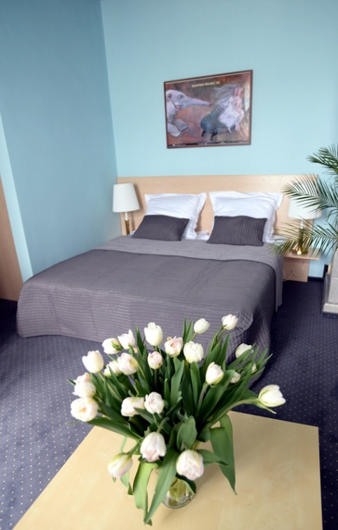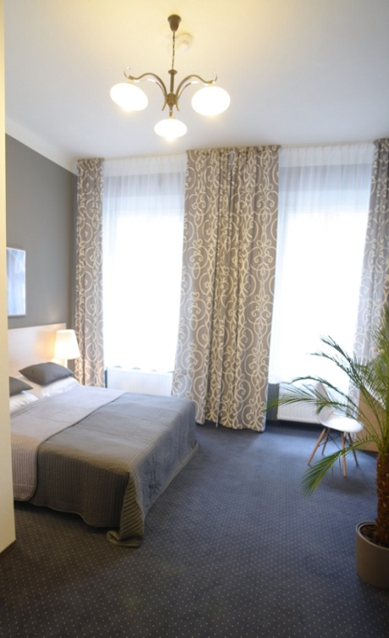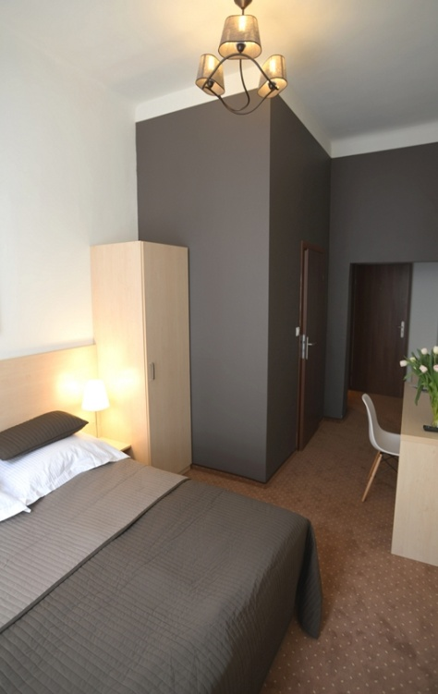

CITY CENTER APARTAMENTS / www.citycenterapartment-krakow.com
ul. Gołębia 8, 31-007 Kraków / ul. Karmelicka 5
Walking distance: 7minutes from the Academy of Music in Kraków
Services: free wireless internet, satellite TV
Breakfast: included
Booking e-mail: info@citycenter-krakow.pl
Prices per person/room: 207 PLN

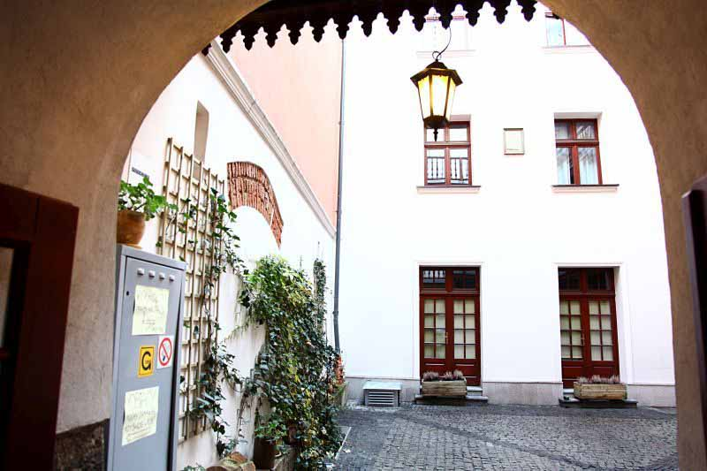
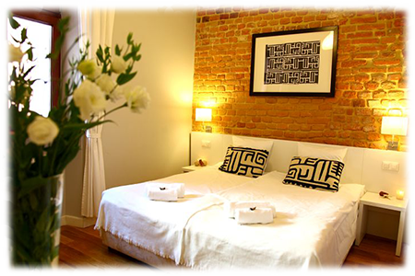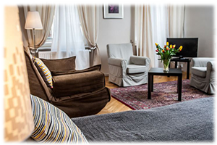

Musical Krakow Apartments
www.facebook.com/apartamentyMuzycznyKrakow/?ref=hl
ul. Karmelicka 5
Walking distance: 10minutes from the Academy of Music in Kraków
Services: free wireless internet, satellite TV
Breakfast: included
Booking e-mail: info@citycenter-krakow.pl
Prices per person/room: 207 PLN

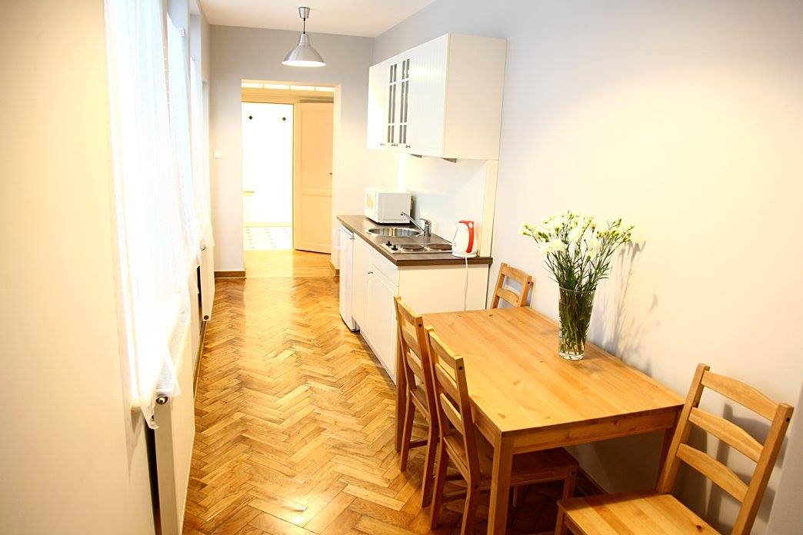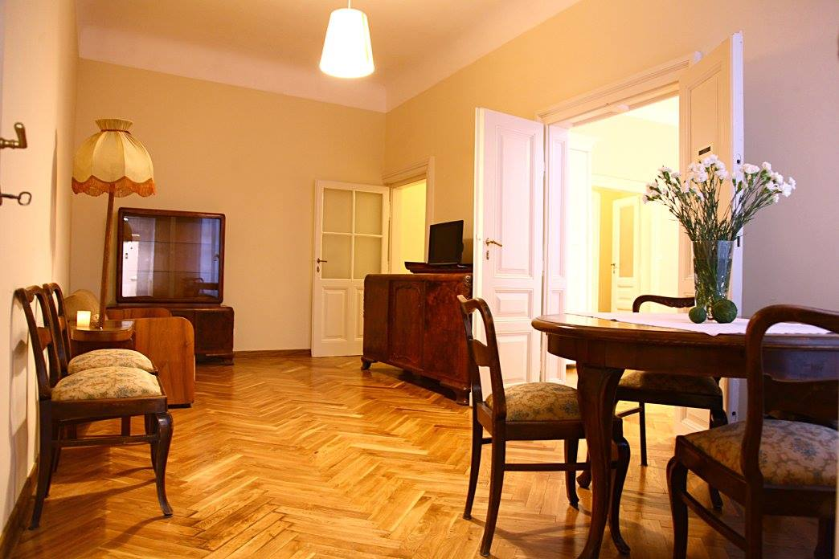
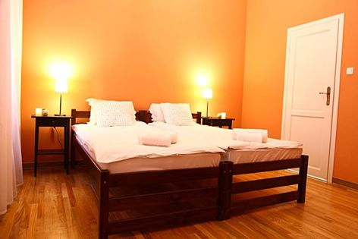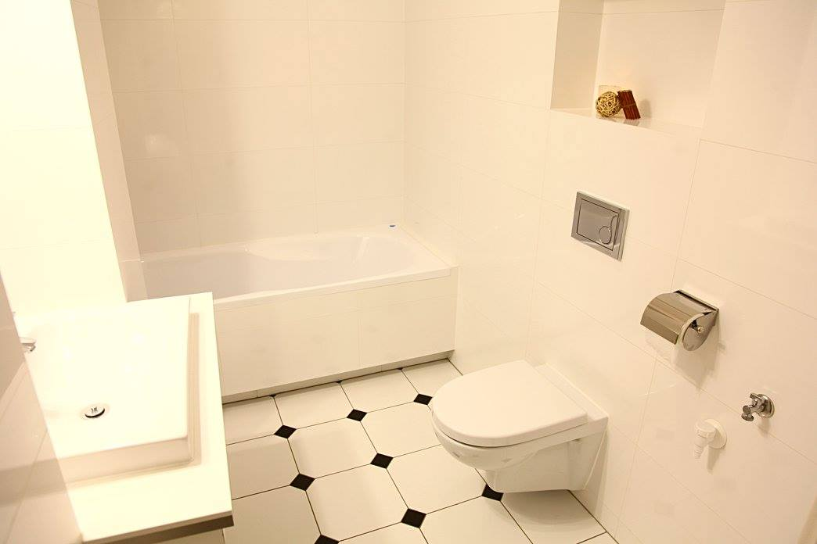

FLORIAN APARTAMENTS /
www. apartamenty-florian.pl
ul. Starowiślna 41-43 , Kraków – Kazimierz / ul. Zyblikiewicza 15
Walking distance: 10 minutes / 3 minutes from the Academy of Music in Kraków
Services: free wireless internet, satellite TV
Breakfast: included
Booking e-mail: zbigniew@apartamenty-florian.pl
Prices per person/room: 200 PLN

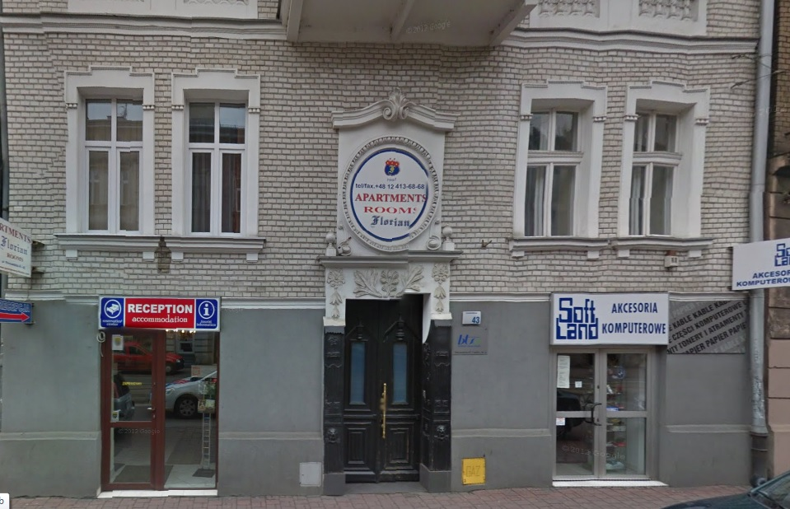
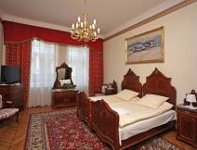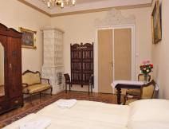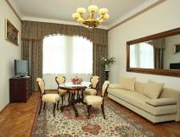

CAMPANILE CRACOW /
www.campanile-cracovie.pl

Class: Two stars 2*
Street: św. Tomasza 34, 31-023 Kraków
Walking distance: just across the Street of the Academy of Music in Kraków
Services: free wireless internet, satellite TV
Breakfast: included
Booking e-mail: krakow@campanile.com
Prices per person/room: about 350 PLN

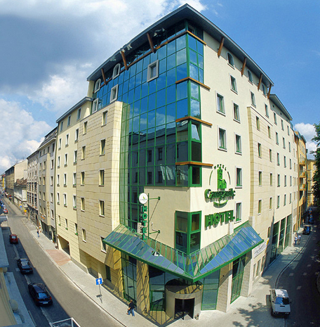
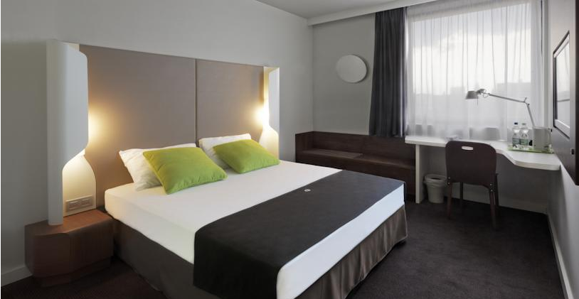

HOTEL WAWEL / www.hotelwawel.pl

Class: Three Stars 3*
Street: Poselska 22, Kraków
Walking distance: 13 minutes from the Academy of Music in Kraków
Services: free wireless internet, satellite TV
Breakfast: included
Booking e-mail: recepcja@hotelwawel.pl
Prices per person/room: about 350 PLN

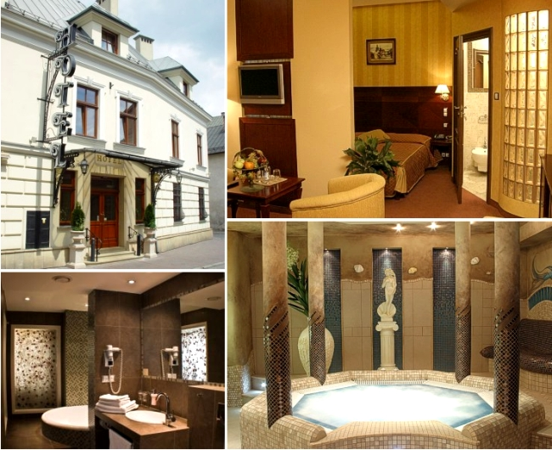

HOTEL WYSPIAŃSKI /
www.hotel-wyspianski.pl
Class: Three Stars 3*
Street: Westerplatte 15, 31-033 Kraków
Walking distance: 1 minutes from the Academy of Music in Kraków
Services: free wireless internet, satellite TV
Breakfast: included
Booking e-mail: wyspianski@janpol.com.pl
Prices per person/room: 420 / 460 PLN

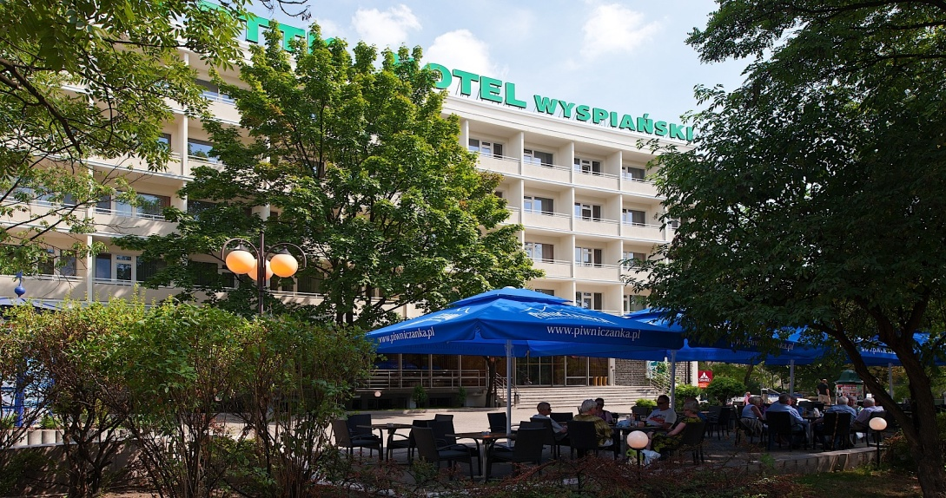
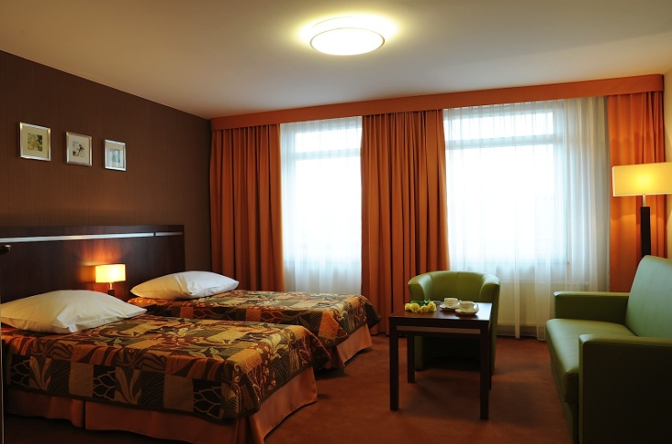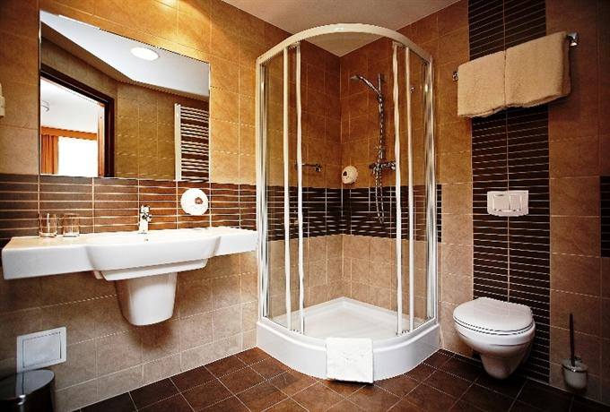

HOTEL WIT STWOSZ / hwww.hotelws.pl

Class: Three Stars 3*
Street: Mikołajska 28, 31-027 Kraków
Walking distance: 2 minutes from the Academy of Music in Kraków
Services: free wireless internet, satellite TV
Breakfast: included
Booking e-mail: hotel@hotelws.pl
Prices per person/room: 350 PLN

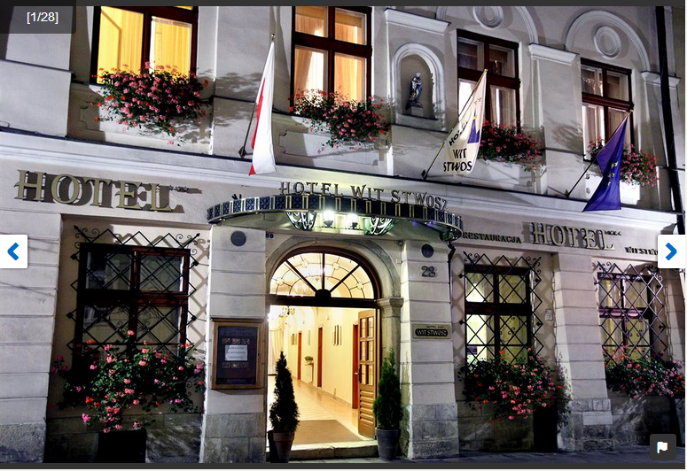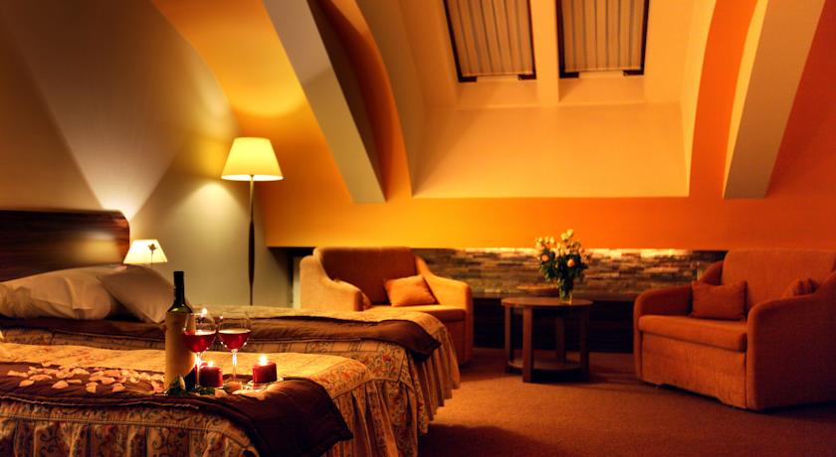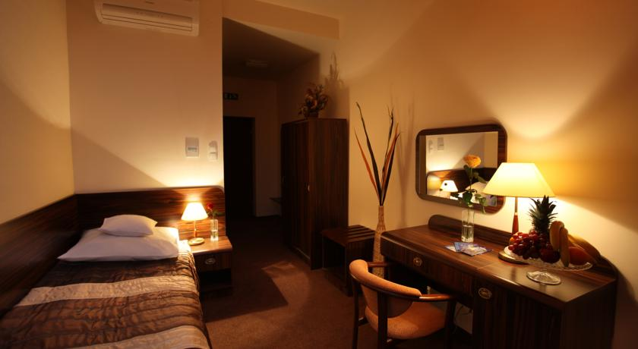

HOTEL POLONIA
Class: Three Stars 3*
Street: Basztowa 25, 31-125 Kraków
Walking distance: 4 minutes from the Academy of Music in Kraków
Services: satellite TV
Breakfast: included
Booking e-mail: http://www.hotel-polonia.com.pl/rezerwacja-ang.php

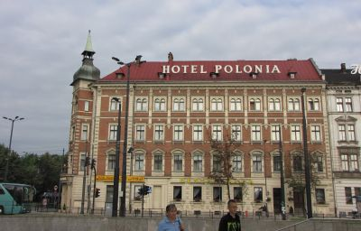

HOTEL EUROPEJSKI
Class: Three Stars 3*
Street: ul. Lubicz 5, 31-034 Kraków
Walking distance: 4 minutes from the Academy of Music in Kraków
Services: satellite TV, WIFI, Xavier Beauty & Spa
Breakfast: included
Booking e-mail: http://www.hoteleuropejskikrakow.com/home.html

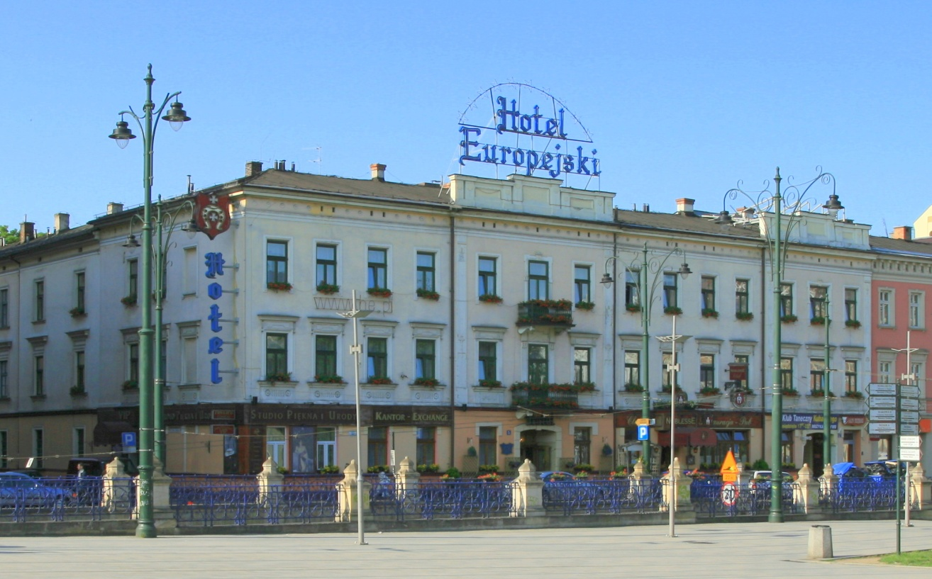

HOTEL POLLERA
Class: Three Stars 3*
Street: ul. Szpitalna 30, 31-024 Kraków
Walking distance: 3 minutes from the Academy of Music in Kraków
Services: satellite TV
Breakfast: included
Booking e-mail: http://www.pollera.com.pl/en,main.php

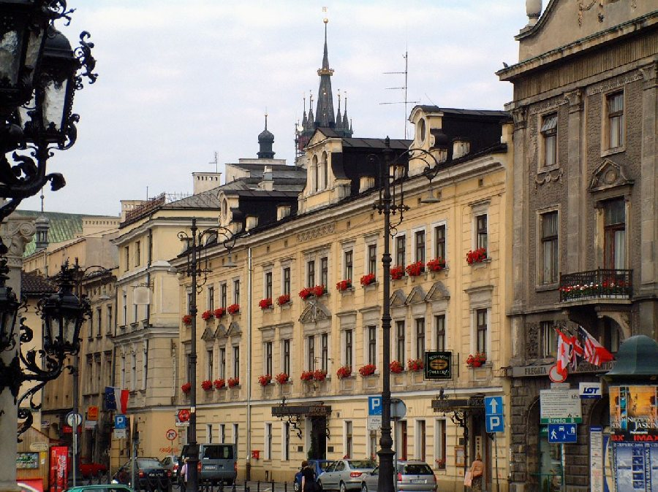

HOTEL WARSZAWSKI
Class: Three Stars 3*
Street: ul. Pawia 4-6, 31-154 Kraków
Walking distance: 4 minutes from the Academy of Music in Kraków
Services: satellite TV
Breakfast: included
Booking e-mail: http://www.hotelwarszawski.pl/indexen.php

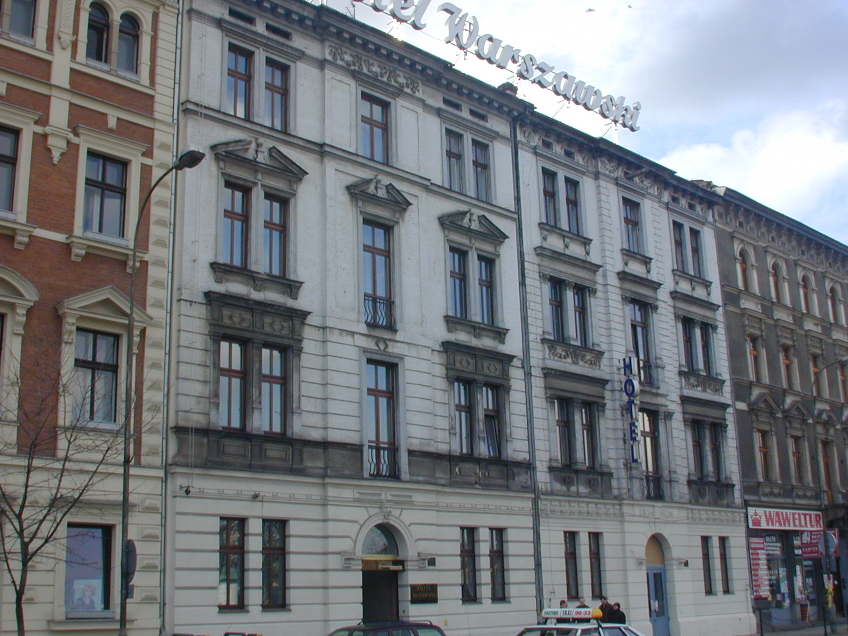

ANDEL’S

Class: Four Stars 4*
Street: Pawia 3,
Walking distance: 6 minutes from the Academy of Music in Kraków
Services: free wireless internet, satellite TV
Breakfast: included
Booking e-mail: reservation.andels-cracow@viennahouse.com
Prices per person/room: 140/160 EURO

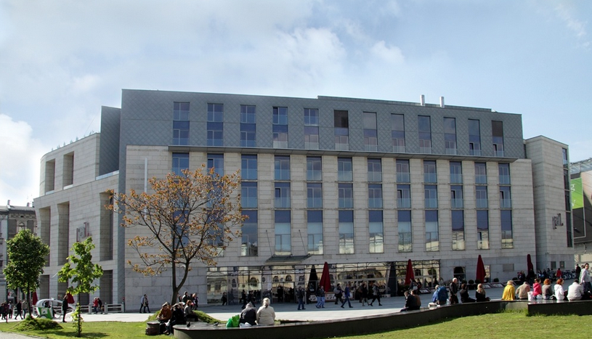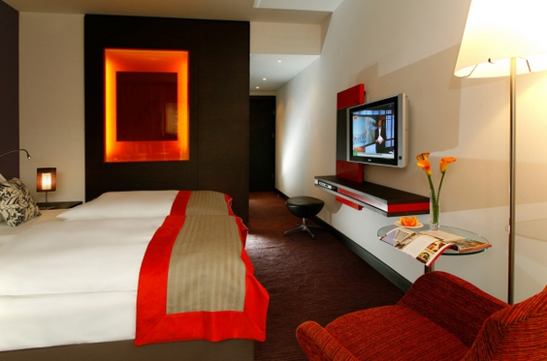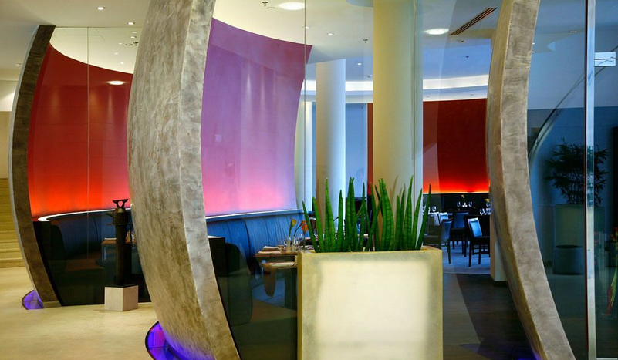

HOTEL UNICUS / www.hotelunicus.pl
Class: Four Stars 4*
Street: ul. Św. Marka 20, 31-020 Kraków
Walking distance: 4 minutes from the Academy of Music in Kraków
Services: free wireless internet, satellite TV
Breakfast: included
Booking e-mail: recepcja@hotelunicus.pl
Prices per person/ twin room: 620 PLN

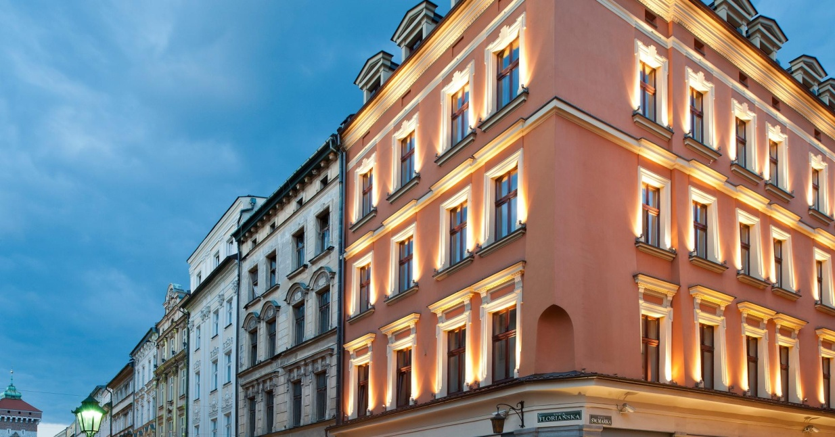

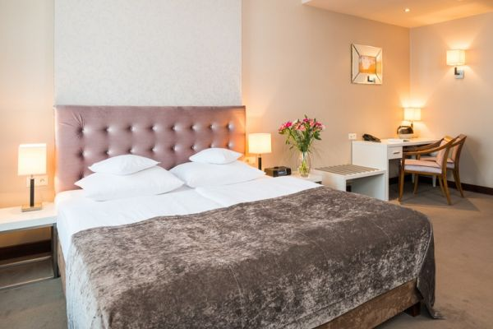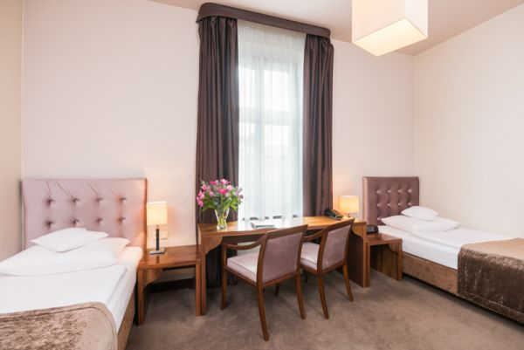

HOTEL POD RÓŻĄ / www.podroza.hotel.com.pl

Class: Four Stars 4*
Street: Floriańska 14, 31-021 Kraków
Walking distance: 4 minutes from the Academy of Music in Kraków
Services: free wireless internet, satellite TV
Breakfast: included
Booking e-mail: pod-roza@hotel.com.pl
Prices per person/room: 650 / 720 PLN

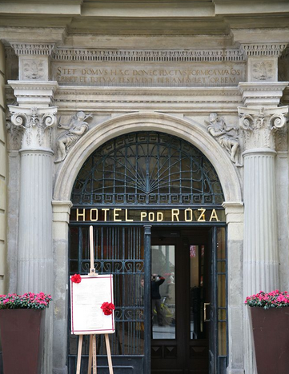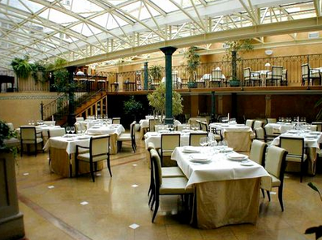
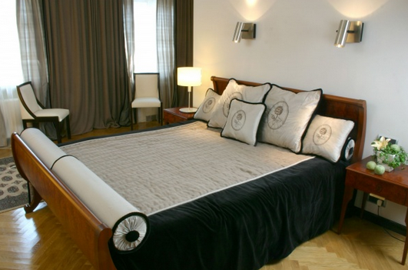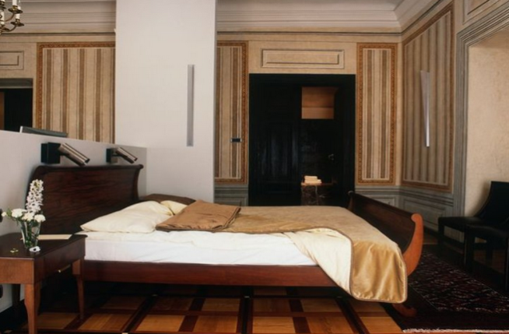

RADDISON BLUE / www.radissonblu.com/pl/hotel-krakow

Class: Five stars 5*
Street: Straszewskiego 17, 31-100 Kraków
Walking distance: 15 minutes from the Academy of Music in Kraków
Services: free wireless internet, satellite TV, sauna and fitness
Breakfast: included
Booking e-mail:
Prices per person/room: 650 / 720 PLN

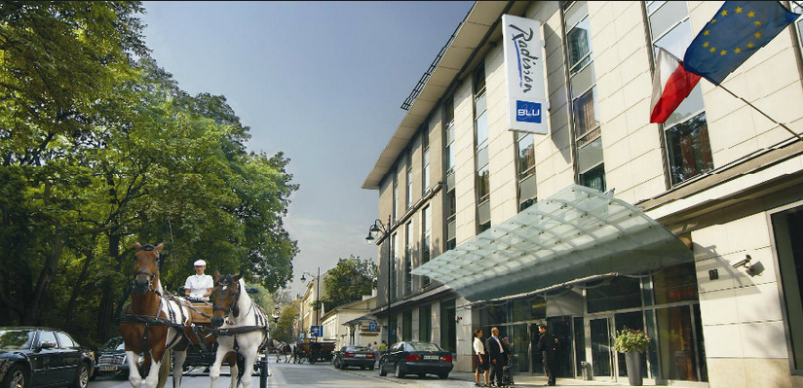
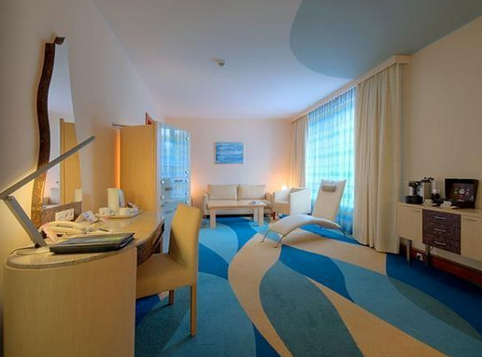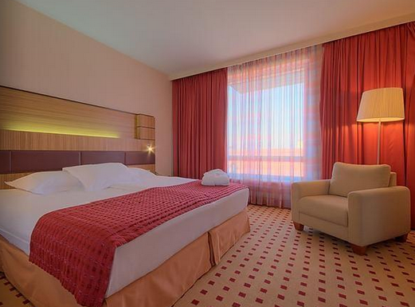

HOTEL SHERATON
Class: Five Stars 5*
Street: Powiśle 7, 31-101 Kraków
Walking distance: 20 minutes from the Academy of Music in Kraków
Services: All inclusive
Breakfast: included
Booking e-mail: http://www.sheratongrandkrakow.com/

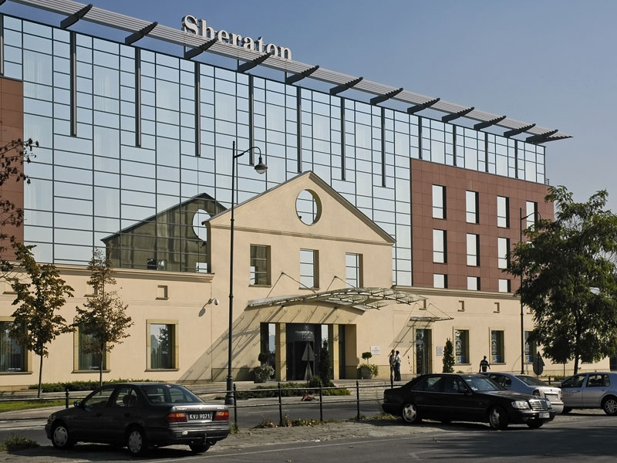

HOTEL NA GRÓDKU
Class: Five Stars 5*
Street: Na Gródku 4, 31-028 Kraków
Walking distance: 3 minutes from the Academy of Music in Kraków
Services: All inclusive
Breakfast: included
Booking e-mail: http://www.donimirski.com/en/hotel-grodek-page-73677

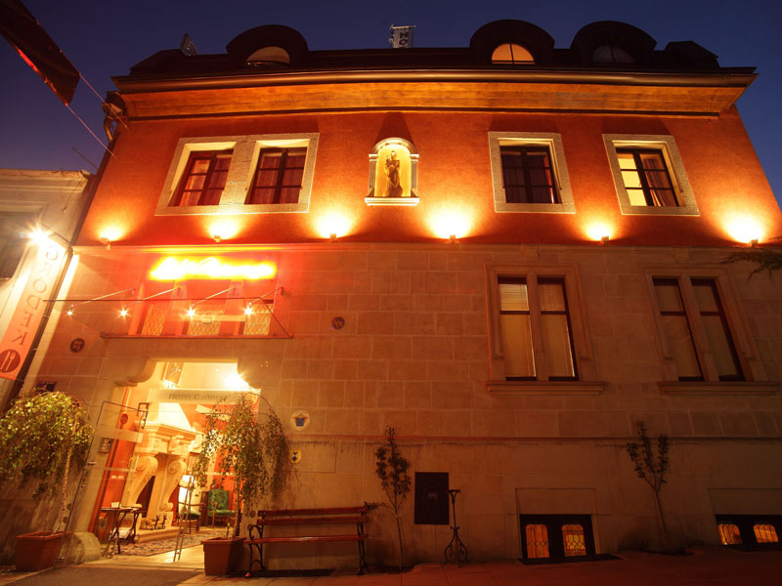

YOUR PLACE – Apartments in Krakow
ul. Biskupia 4/3, 31-144 Kraków, Poland
Email: ask@yourplace.pl
Tel. +48 123 50 5850
+48 665 146 629
Fax: +48 12 2629 748

http://en.yourplace.pl/

Since it might be hard to find hotels in Krakow, our organizer also found apartments to rent.

